Lab 8 Results

Student: Diego Rosenberg de Angoitia

Net ID: dr3432

N#: N11409122

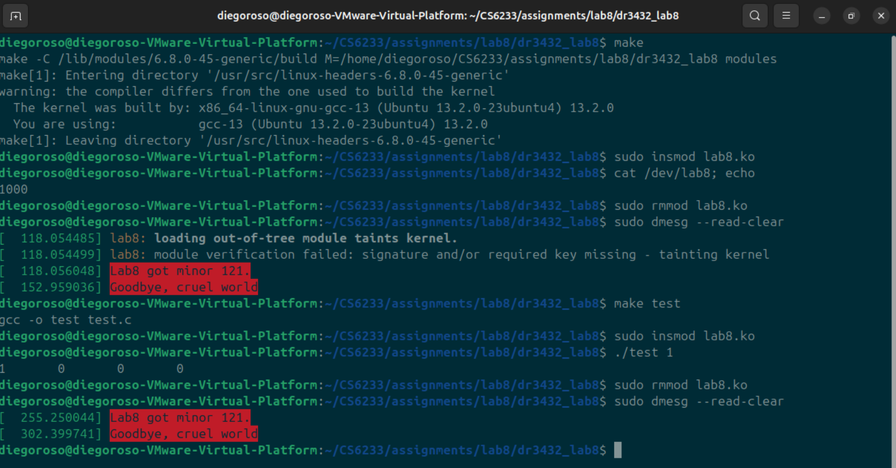

NOTE: Added a test.c file that can be used to test reading of /dev/lab8 file.

Usage: ./test <number of bytes to read>

NOTE: Since we do not have a close function that is created we have to delete the driver before doing another operation, if not the module will show an error: Device or resource busy.